**♥ Queen of Hearts ♥**

*Hidden primary antagonist of the story. At first, she will be shown as a caring individual who wishes to help Ace of Spades achieve her goals. Later on, Beauty will uncover that the Queen is an ambitious individual bent on turning everyone into her own personal card soldier army, thus taking over the entire world.*

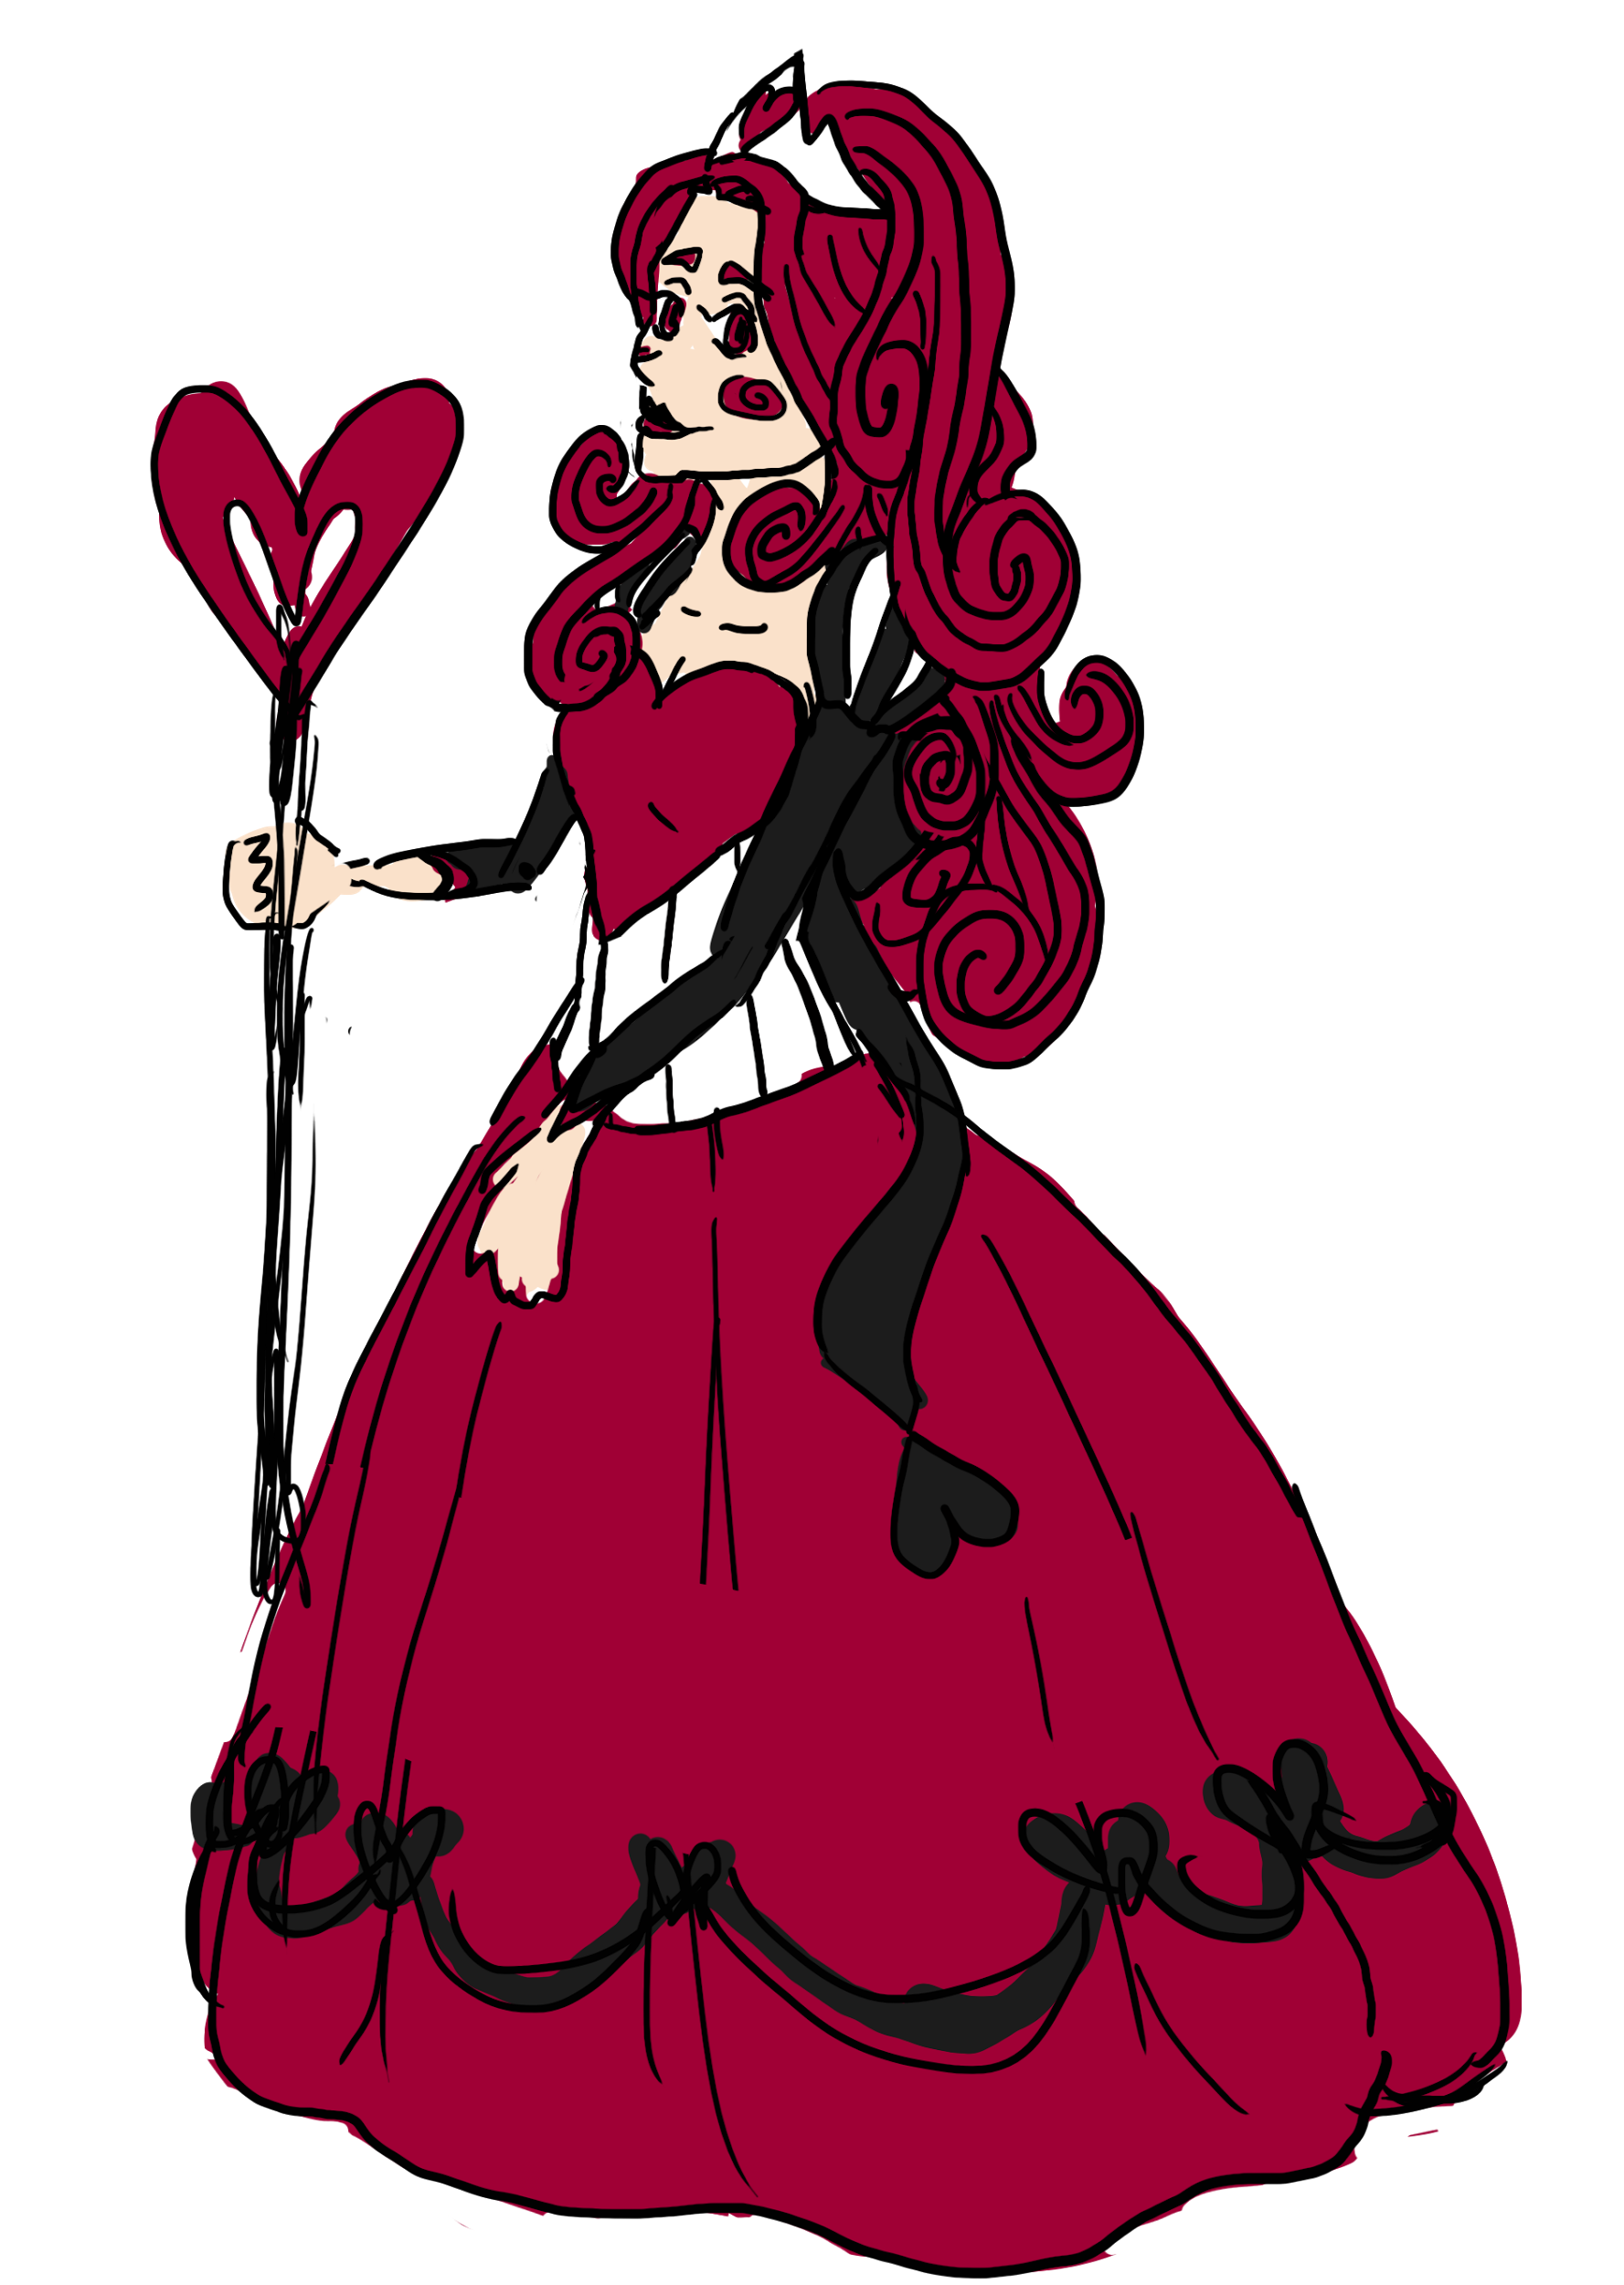

**mini bio**

Wishes to become the Queen over all the land, primarily by turning everyone else into a card soldier that is obedient to her will.